NDSA Student Login Instructions:

1. Have your students log into their computers with the following username/password:

Username: act2015

Password: act123

*Do NOT have them login under their own username/password!

2. Then, have students find the secure browser icon.
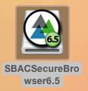
3. The browser will direct them to pick their state. (ND)

4. Then, it will direct them to choose a test. They should choose Summative Test.

5. Staff must create a test session for the student to move to this step.

Next, students will need to type in their SSID, first name and test ID (from instructor. The instructor can find that in the top right hand corner of their screen. They will time in the words in the first field and the number(s) in the second field.

6. Along the way, they will be prompted to be sure that their individual information is correct. They should just click ‘yes’ and go on.

5. Then, they will get a list of tests and their test will be highlighted in green. They should click that and then begin.

6. At this point, the teacher will have to approve the test. You will see that screen in the upper right hand section.
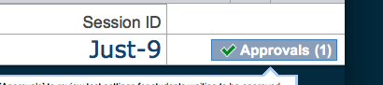

7. Then the student will be given a set of information asking if this is their test. They should click ‘yes, start my test’.

8. One screen that will appear for students is a sound test icon. Have the student click the sound icon and then click ‘yes’.

9. Finally, the student will be directed to start their test.

